***World History***

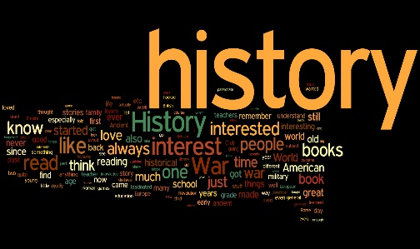

[This Photo](http://scustodio-libertyschool.wikispaces.com/9th+Grade+World+History) by Unknown Author is licensed under [CC BY-SA](https://creativecommons.org/licenses/by-sa/3.0/)

***Mrs. Cherri Patterson***

***EXCEL Academy 2019-2020 Academic Year***

[cherri.patterson@henry.k12.ga.us](mailto:cherri.patterson@henry.k12.ga.us)

***room: #106***

Course Textbook: World History: HMH Social Studies

Supplementary texts:

Active Classroom <https://www.activeclassroom.com/log_in>

Newsela.com

Readworks.org

The high school world history course provides students with a comprehensive, intensive study of major events and themes in world history. Students begin with a study of the earliest civilizations worldwide and continue to examine major developments and themes in all regions of the world. The course culminates in a study of change and continuity and globalization at the beginning of the 21st century.

**HCTL Standard: As a Henry County graduate, I will use my understanding of continuity and change to analyze a variety of sources, perspective, and historical influences.**

Outline of course based on Henry County Teaching & Learning Standards, Henry Learning Progressions, and the Georgia Standards of Excellence for world history:

1st semester:

Unit 1: Birth of Civilizations (3 weeks)

Unit 2: Age of Empires (5 weeks)

Unit 3: The Middle Ages & Development of the Silk Road Trade Routes

(4 weeks)

Unit 4: Age of Exploration (5 weeks)

2nd semester:

Unit 5: Age of Enlightenment and Revolutions (4 weeks)

Unit 6: Age of Imperialism and Industrial Revolution (5 weeks)

Unit 7: World Wars (4 weeks)

Unit 8: Post World War II and Globalism (4 weeks)

**COURSE GOALS:** As a result of this course, students should:

* Demonstrate understanding of selected themes using knowledge and skills acquired during the school year.
* Develop effective communication skills using a variety of written and oral assignments.
* Develop skills for both presentations and discussions.
* Gain proficiency in researching and in wise use of technology.
* Understand the events of the past are responsible for shaping the world today.
* Read and analyze historical documents for both content and context.
* Think critically & independently through the examination of multiple sources.
* Make judgements & decisions based on multiple sources.
* Articulate learning through the communicative arts.

**Learner Profile:** Students are expected to create a SMART goal and action step at the beginning of each unit. At the end of each unit, student’s will complete a reflection and/or discussion of their progress and takeaways on that particular unit. Students are also expected to upload at least one work sample for each course into their Learner Profile portfolio.

**GRADING POLICY:**

90-100 A 70-73 D Options are available for students who earn a 69

80-89 B 69 and below F or below on a test. Late work will be penalized

74-79 C unless prior approval has been granted.

Traditional school courses are semester long, A/B courses. Block school courses are one semester long full courses.

**CLASSROOM RULES & PROCEDURES:**

Please refer to the Henry County handbook and the EXCEL Academy supplement to the handbook for expectations of student behavior.

* Be Respectful to yourself, others, and other’s belongings.
* Be Responsible for your space including your words and actions.
* Be Ready to begin work when the bell rings.

No food or drink allowed in the classroom except clear, bottled water as outlined in the handbook.

**TECHNOLOGY & CELL PHONES:**

Cell phones should not be out and/or visible in the classroom. This is a school wide expectation. Students who refuse to comply with EXCEL cell phone procedures will be asked to turn the cell phone into office personnel. Refusal to comply with that request will result in disciplinary action per the handbook and PBIS process. Other electronic devices, to include MP3 players, iPods, etc. are not authorized for use in the classroom.

**SUPPLIES:**

Spiral notebook for history use only (Mead Interactive Spiral notebook) if possible

Pencils

Pens

Colored (map) pencils

Pencil pouch

**DISCIPLINE POLICY:**

My classroom discipline policy will adhere to the school wide PBIS process and the expectations outlined in the EXCEL Parent & Student Handbook.

**GOOGLE CLASSROOM:** Course assignments are posted on Google Classroom for student access.